INDEX
CLOUD COMPUTING
S.NO | DATE | CONTENTS | PAGE NO
1 |  | WORKING WITH GOOGLE DRIVE TO MAKE  SPREADSHEET AND NOTES
2 |  | LAUNCH A LINUX VIRTUAL MACHINE
3 |  | TO HOST A STATIC WEBSITE
4 |  | EXPLORING GOOGLE CLOUD FOR THE FOLLOWING A)STORAGE B)SHARING OF DATA  C)MANAGE YOUR CALENDAR,TO-DO LISTS,  D)A DOCUMENT EDITING TOOL
5 |  | WORKING AND INSTALLATION OF GOOGLE APP ENGINE
6 |  | WORKING AND INSTALLATION OF MICROSOFT AZURE
7 |  | TO CONNECT AMAZON REDSHIFT WITH S3 BUCKET
8 |  | TO CREATE AND QUERY A NOSQL TABLE

PROGRAM 1

WORKING WITH GOOGLE DRIVE TO MAKE
SPREADSHEET AND NOTES
AIM:
To create a Spreadsheet using Google drive and to make a notes in spreadsheet

ALGORITHM:

STEP 1: Start the program

STEP 2: Sign in your mail id and open a drive for working in a spreadsheet

STEP 3: Open a my drive and select a Google sheets (spreadsheet).

STEP 4: Make a note & comments in the selected spreadsheet(cells )

STEP 5: Stop the program

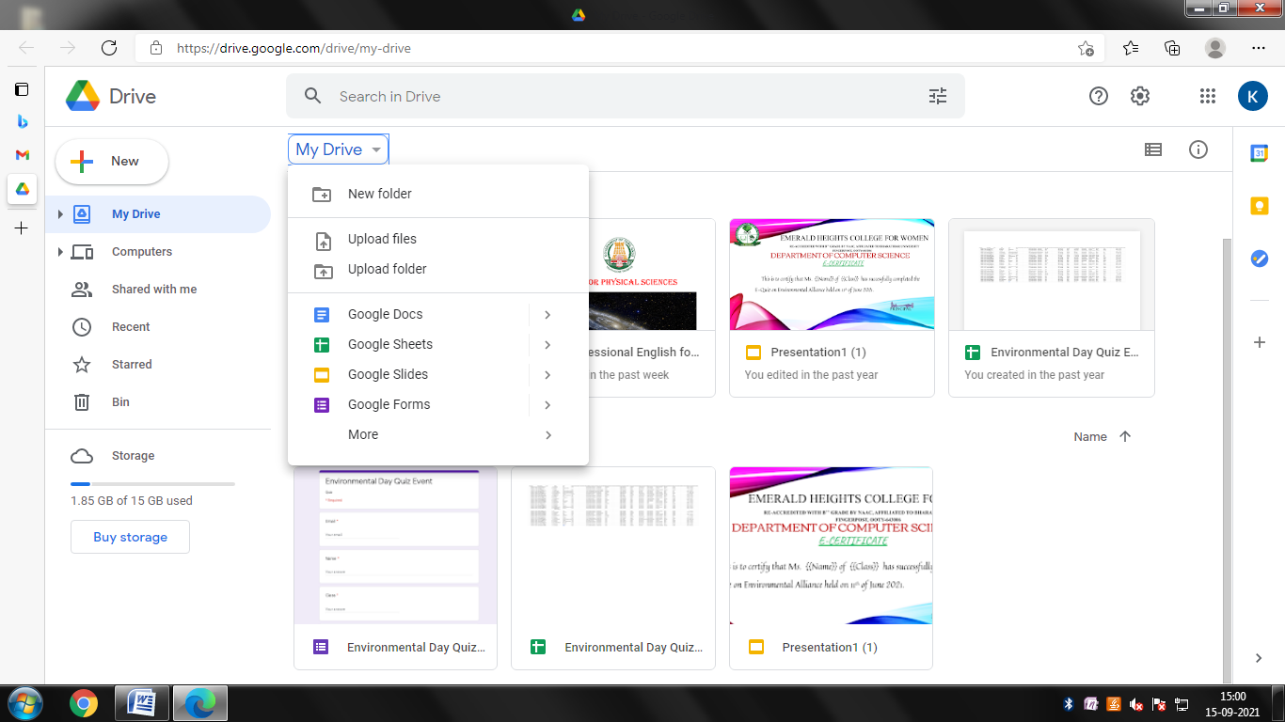

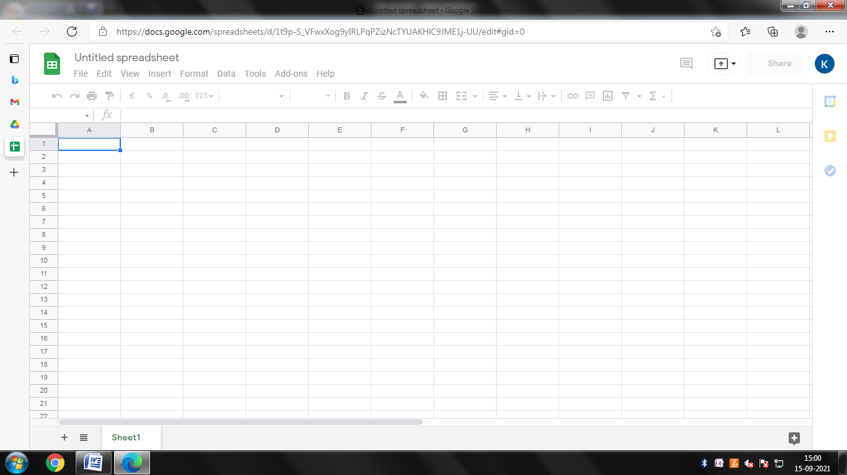

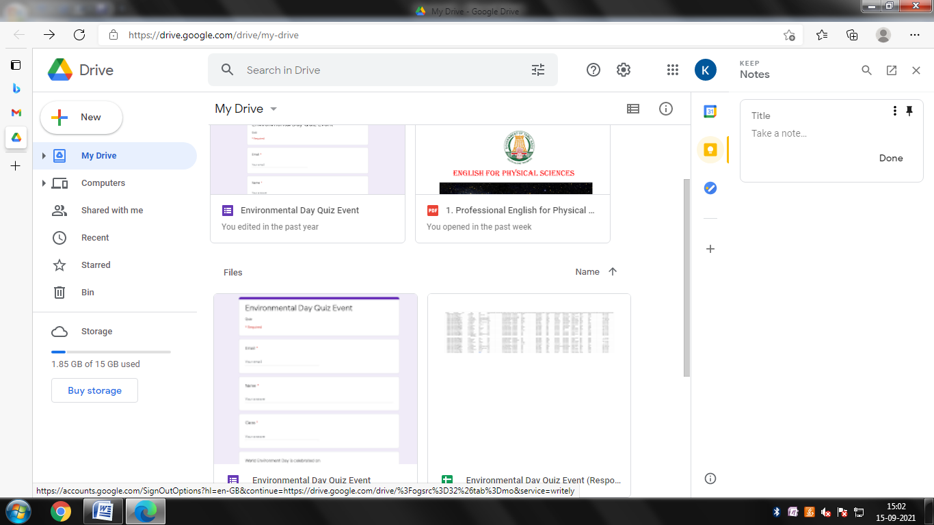
OUTPUT
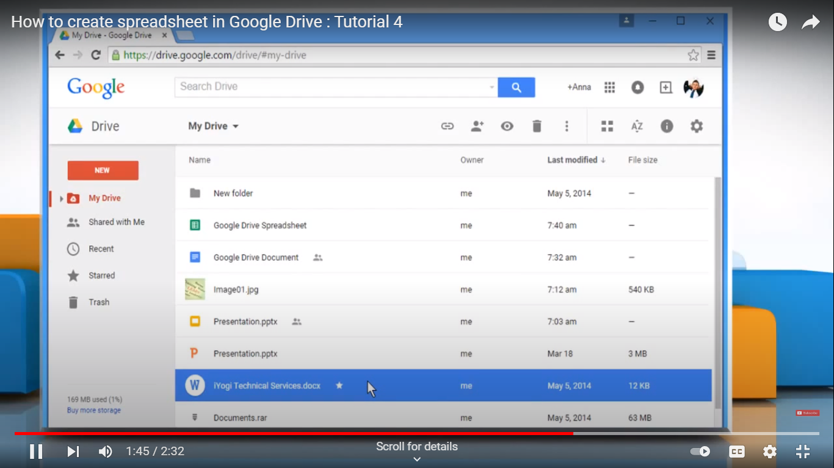

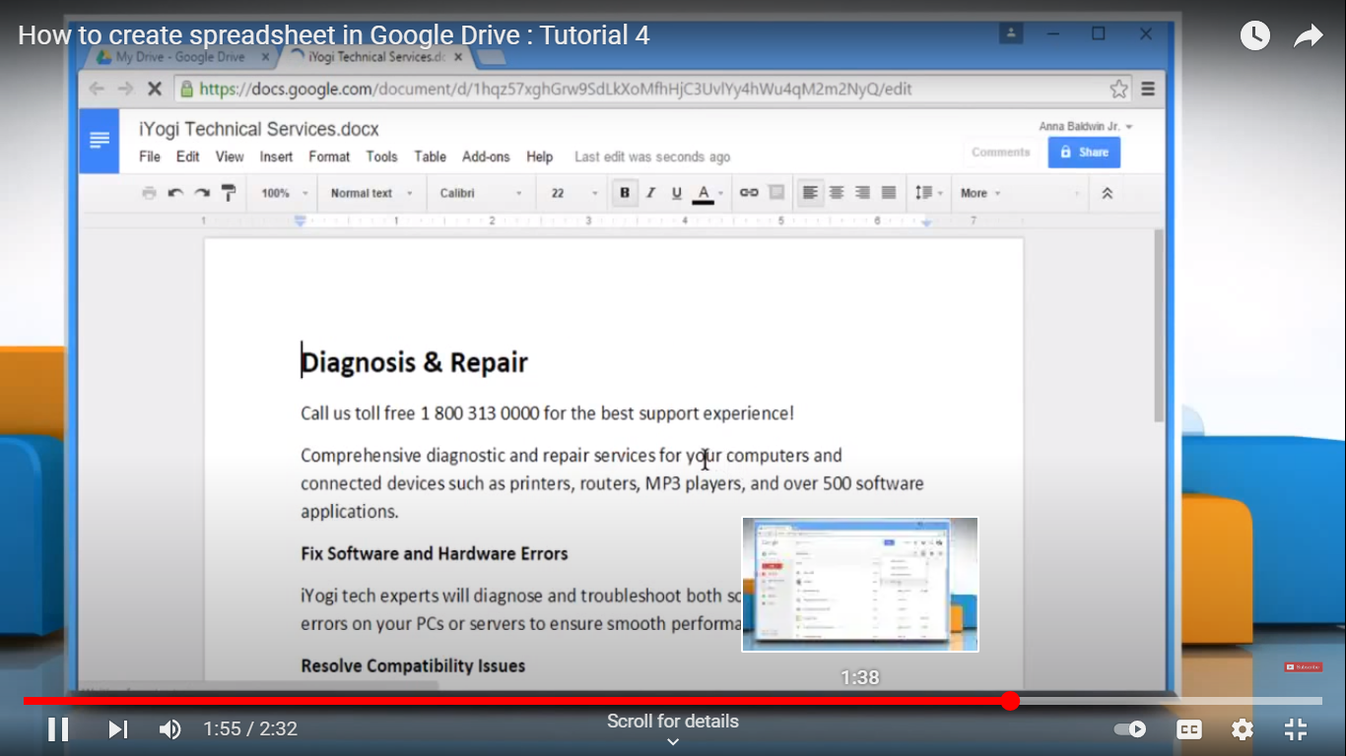

PROGRAM 2
LAUNCH A LINUX VIRTUAL MACHINE
AIM:

To create a program for launching a linux virtual machine

ALOGRITHM:

STEP 1: Start the program

STEP 2: Open a website ubuntu.com for installation of ubuntu operating system

STEP 3: Download the virtual box and select a setting for installation

STEP 4: Open the ubuntu operating system and make a changes on it

STEP 5 : Stop the process

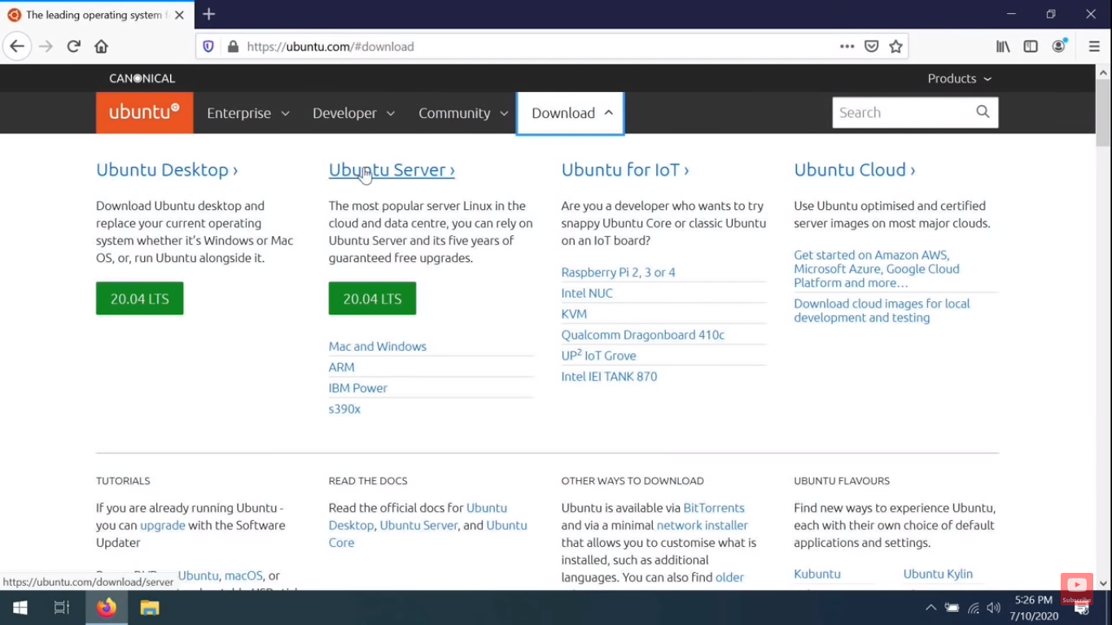

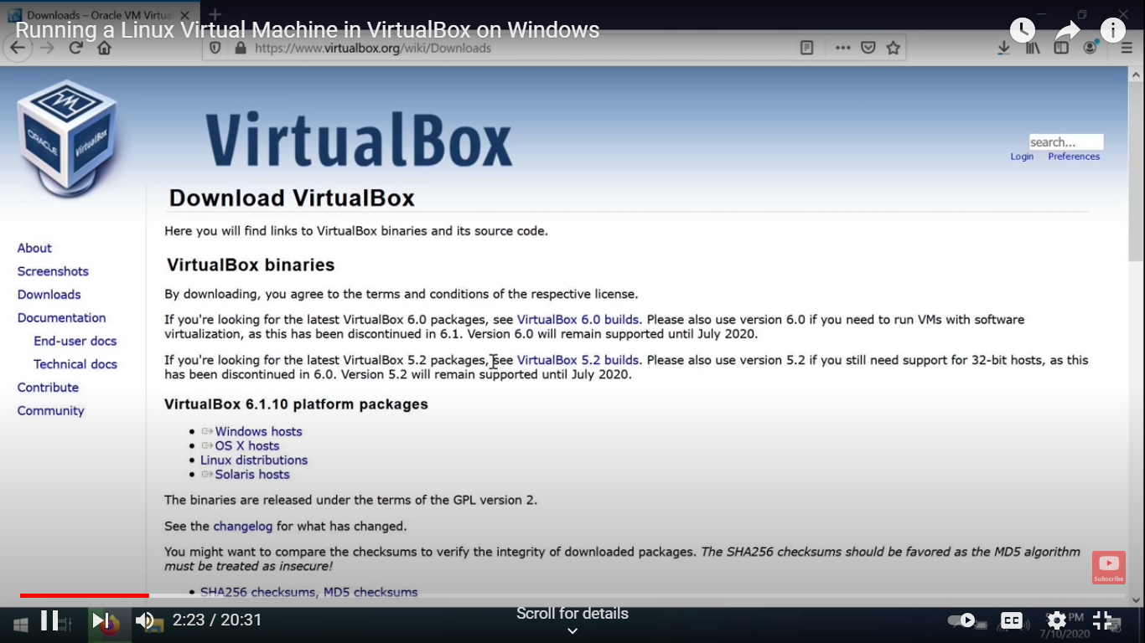

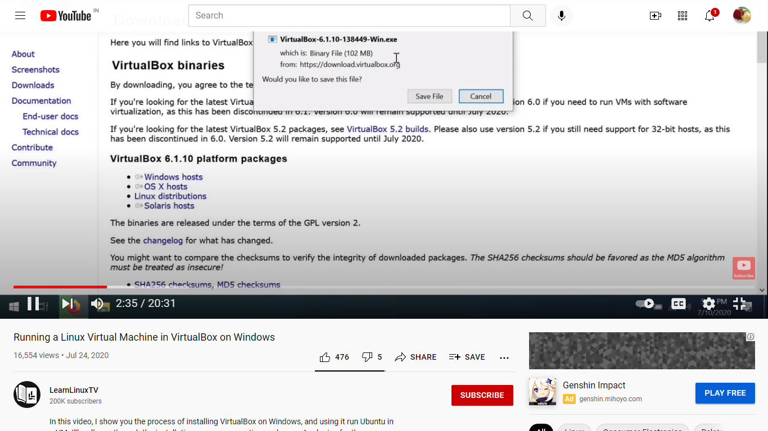

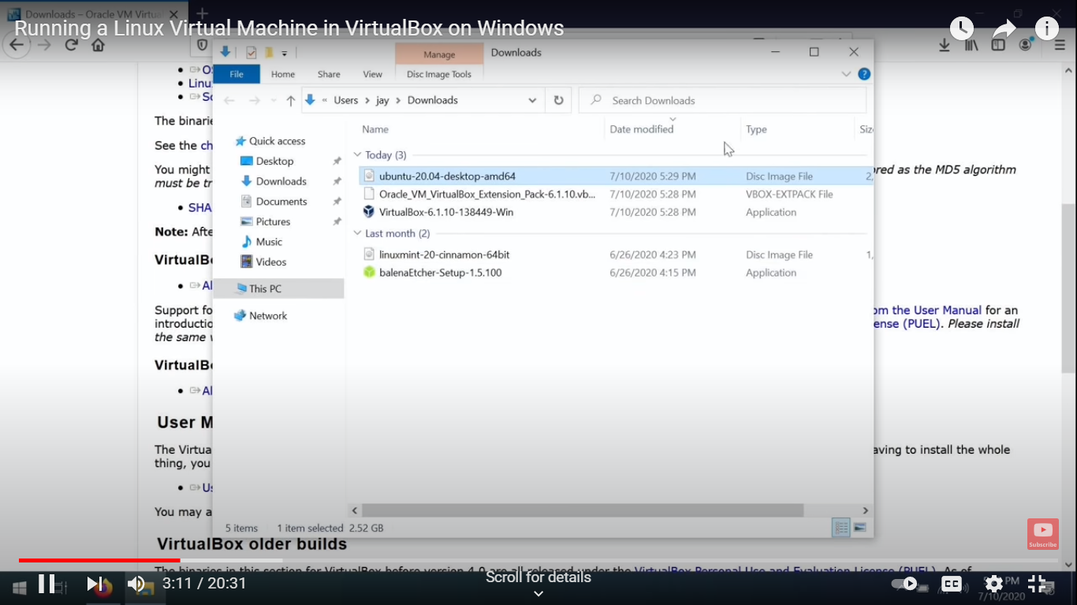

OUTPUT
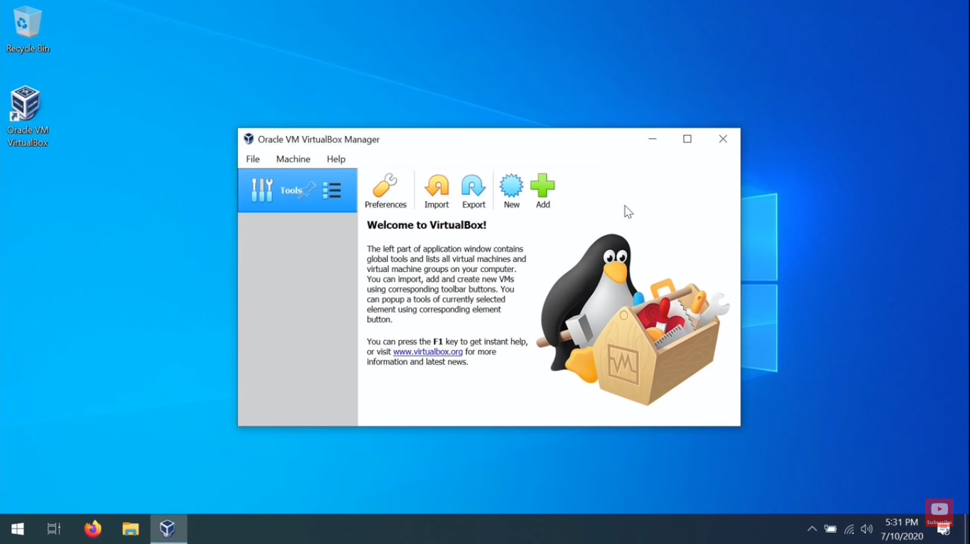

PROGRAM 3
TO HOST A STATIC WEBSITE
AIM:
To create a static website on cloud
ALOGRITHM:
STEP 1: Start the process

STEP 2: Open the Google cloud platform for creating a static website

STEP 3: Create a bucket and set the name of your bucket and give the details of the static website

STEP 4: Give a domain name for the website and make changes in setting and finally display the static
details of the named website

STEP 5: Stop the program

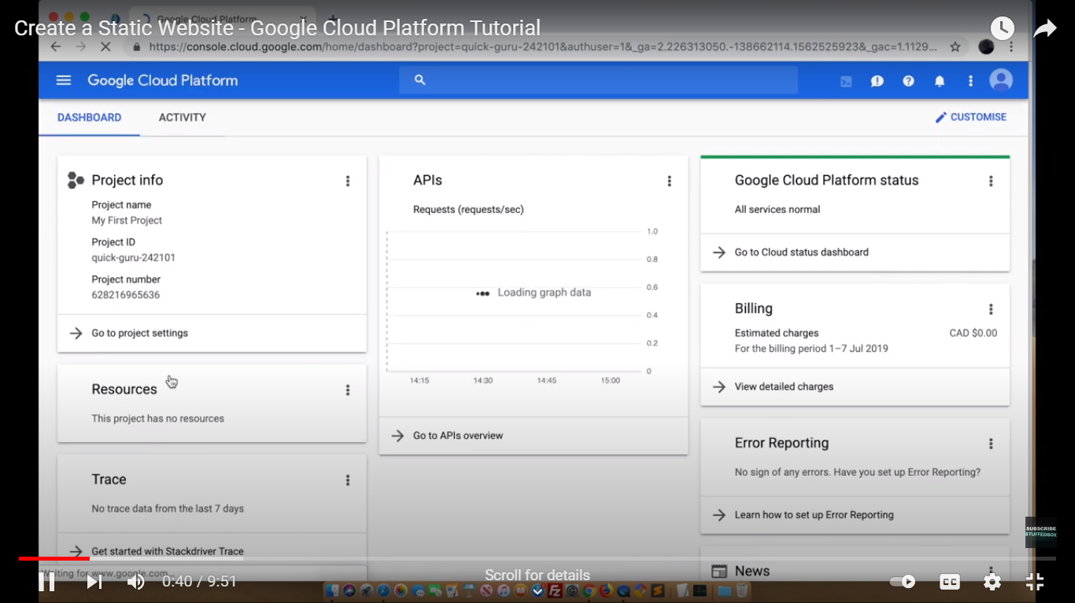

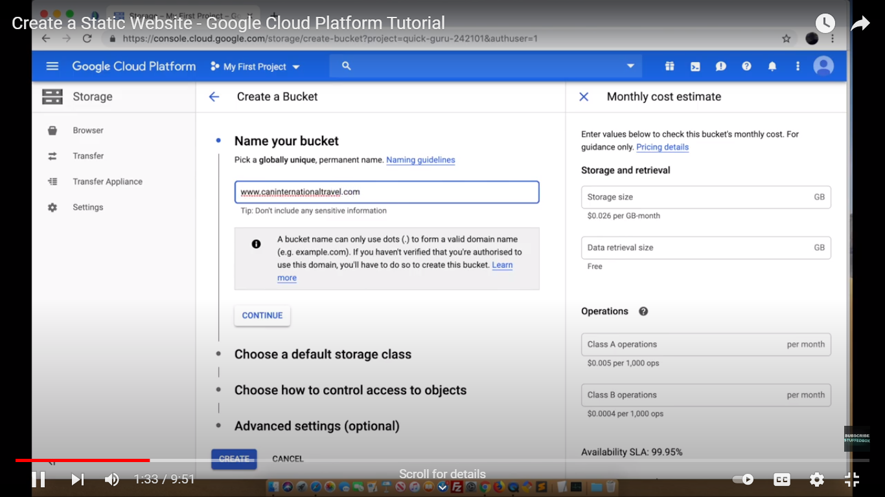

OUTPUT:

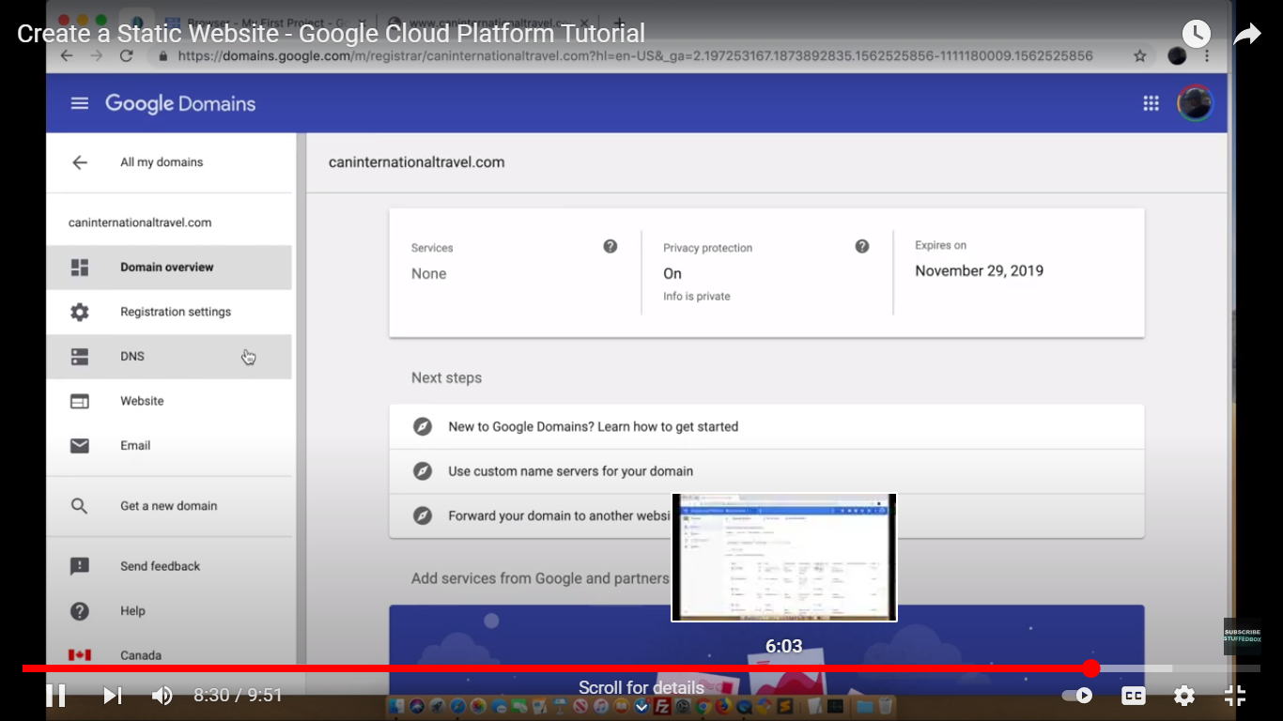
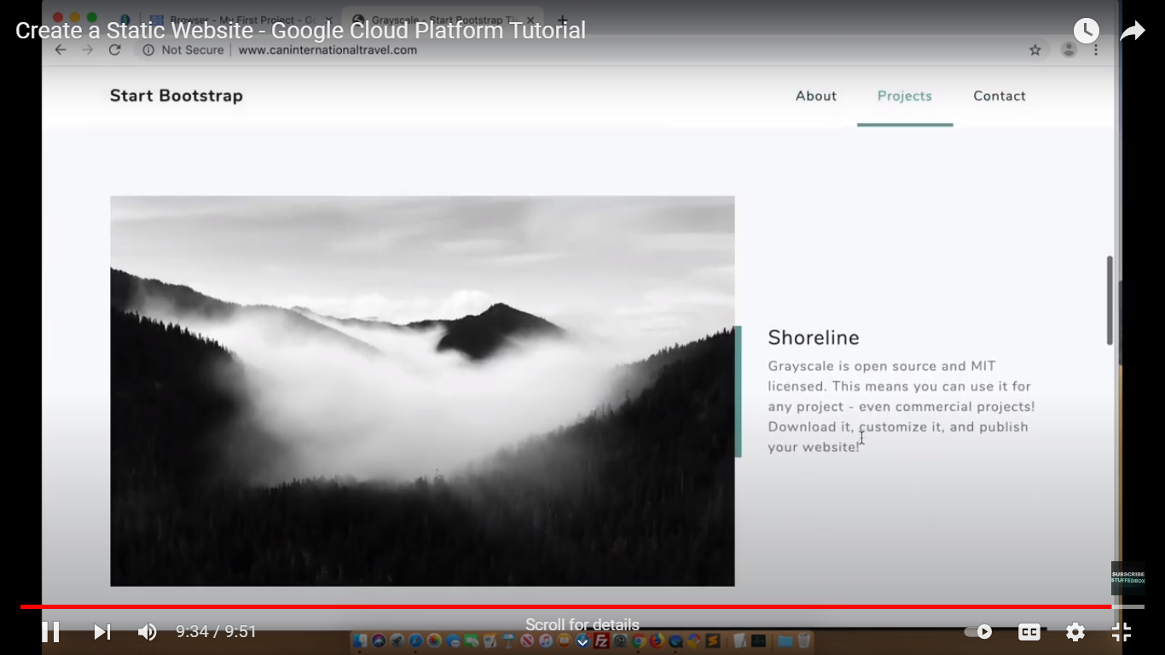

PROGRAM 4
EXPLORING GOOGLE CLOUD

AIM:
To create and exploring Google cloud for the a)Storage b) Sharing of data c)Manage your calendar , to- do list d)Document editing tool
ALOGRITHM:
STEP 1: Start the process
STEP 2: Open a website console.cloud.google.com for using the Google cloud platform
STEP 3: Click the dash board for opening the menu storage. If we open the menu it displays the storage of file in the drive
STEP 4: If we want to share the files means select a sharing of data menu from dash board and share the file
STEP 5: If we want to use the calendar for displaying the files accessing details in the right side of the form
STEP 6: Click the to-do list and document editing tool for edit the document
STEP 7: Stop the process

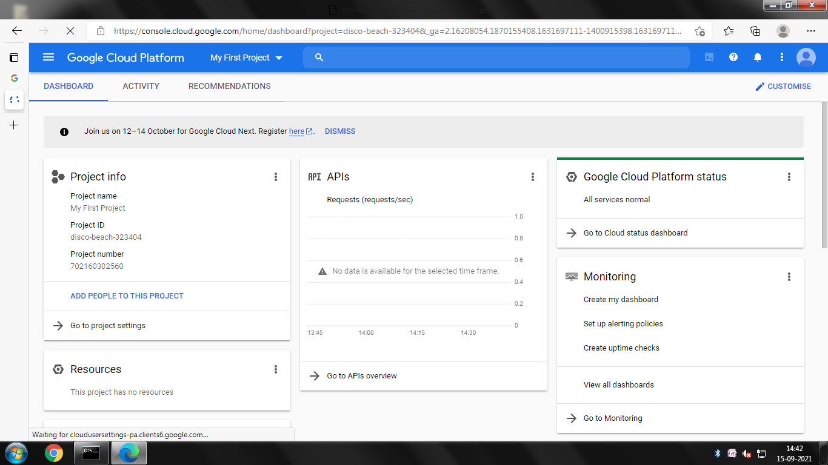

OUTPUT
Storage:

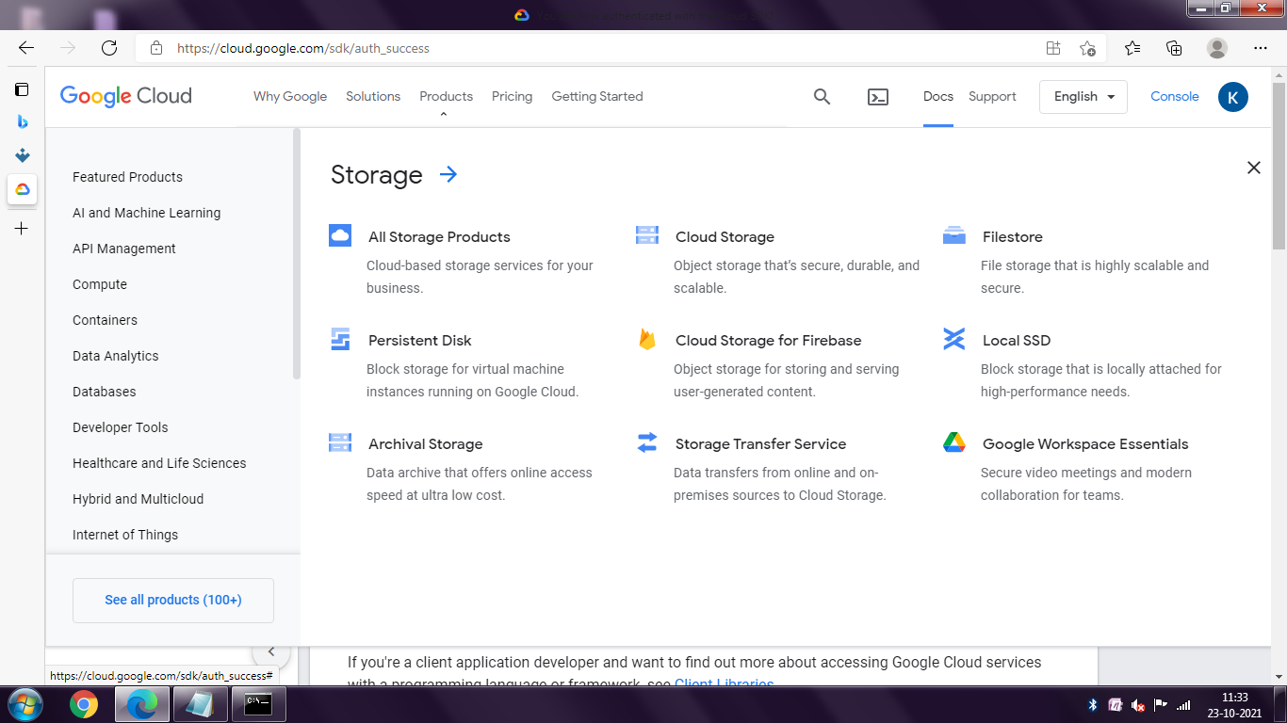
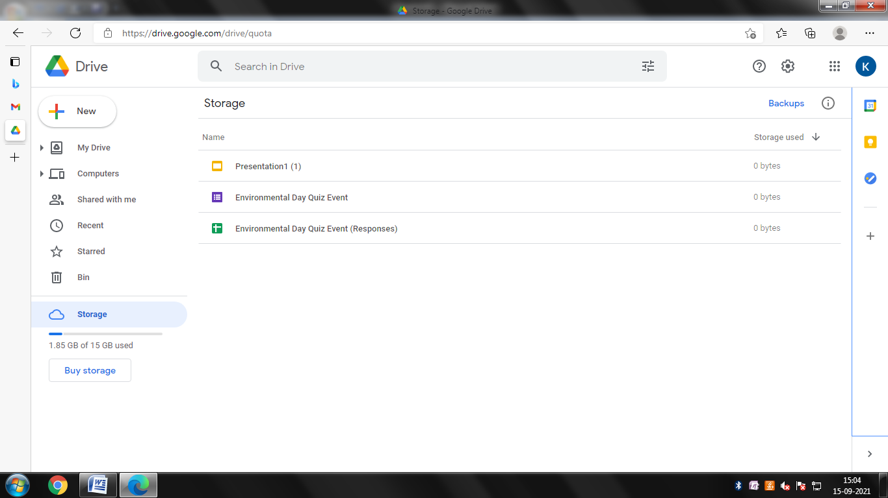

Sharing of data:

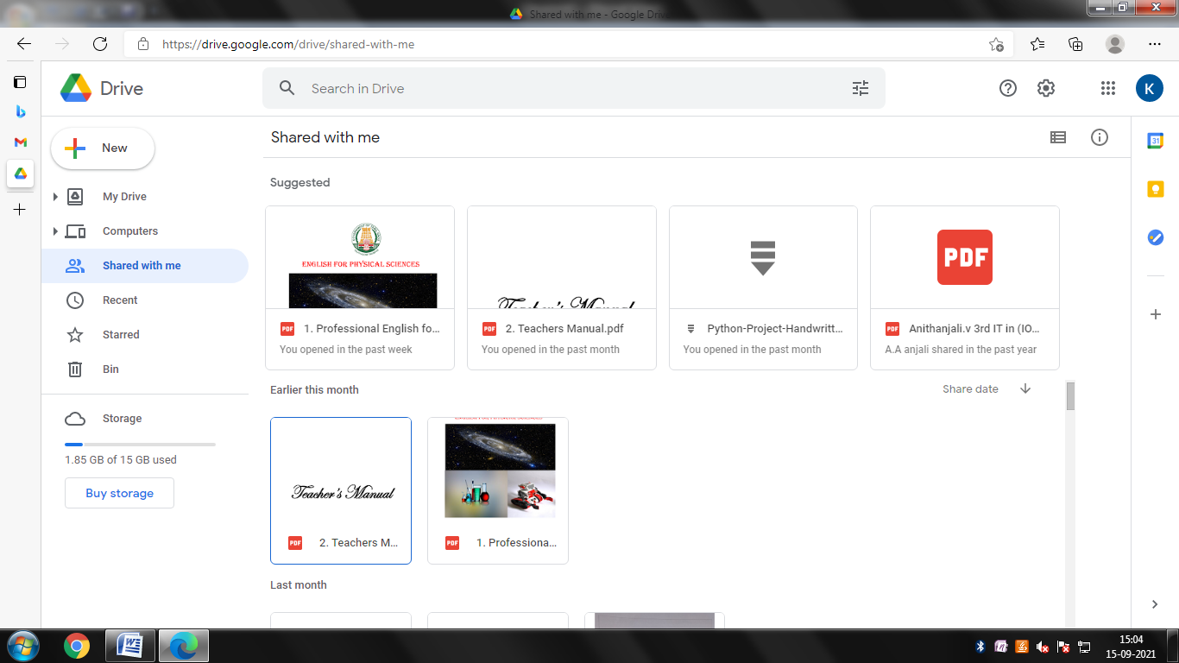

Calendar:

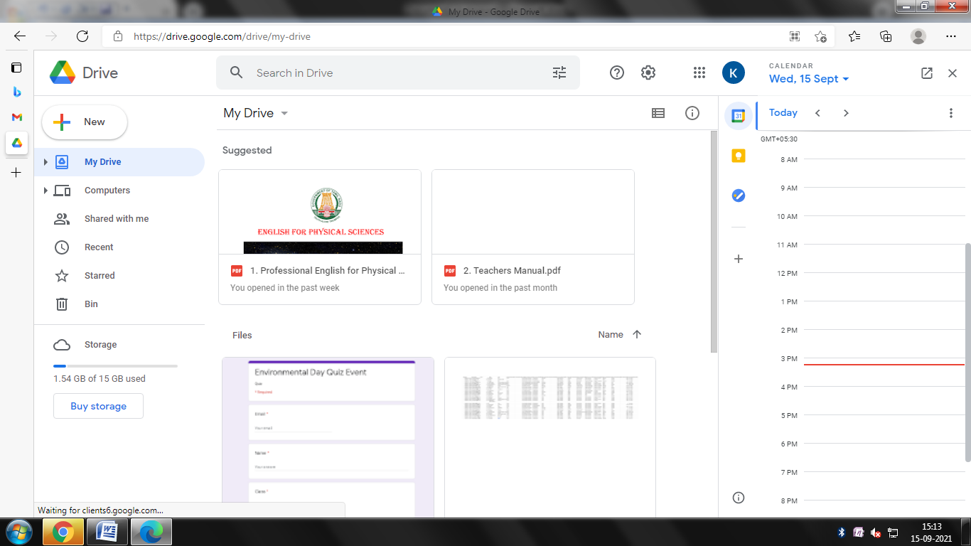

To do list

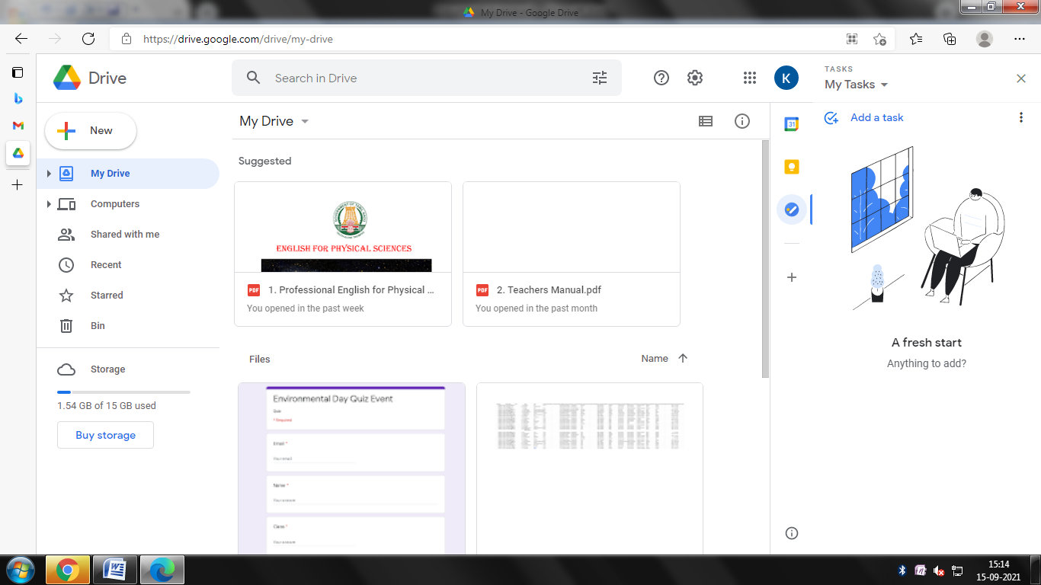

Document editing tool:

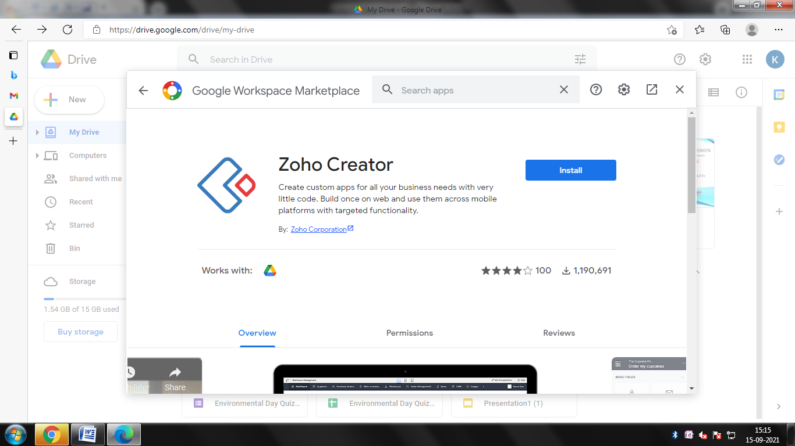

PROGRAM 5
WORKING AND INSTALLATION OF GOOGLE APP ENGINE

AIM:
To create a program for working and installation of Google app engine
ALOGRITHM:
STEP 1: Start the process
STEP 2: Open a website console cloud .google.com for using the Google cloud platform
STEP 3: Click the dash board for opening the menu storage
STEP 4: Install the app engine and create the name of project
STEP 5: Open the quick start button in the right side and click the start button
STEP 6: Select the python for coding class process
STEP 7: Stop the process

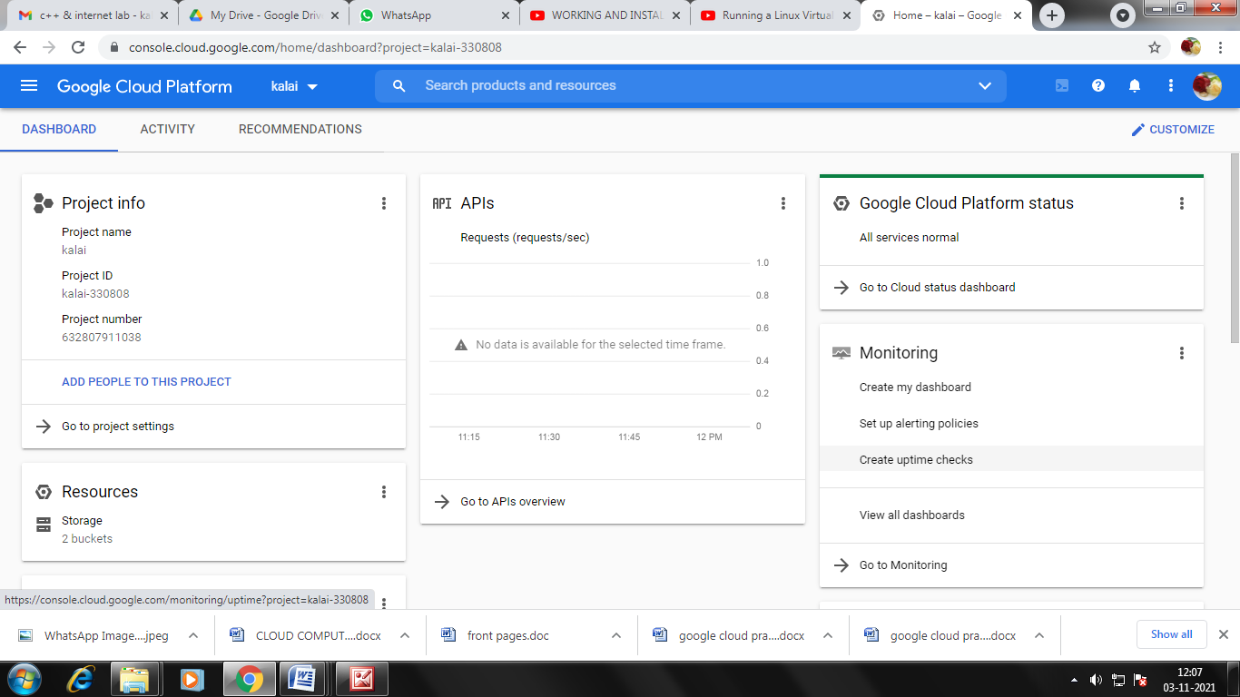

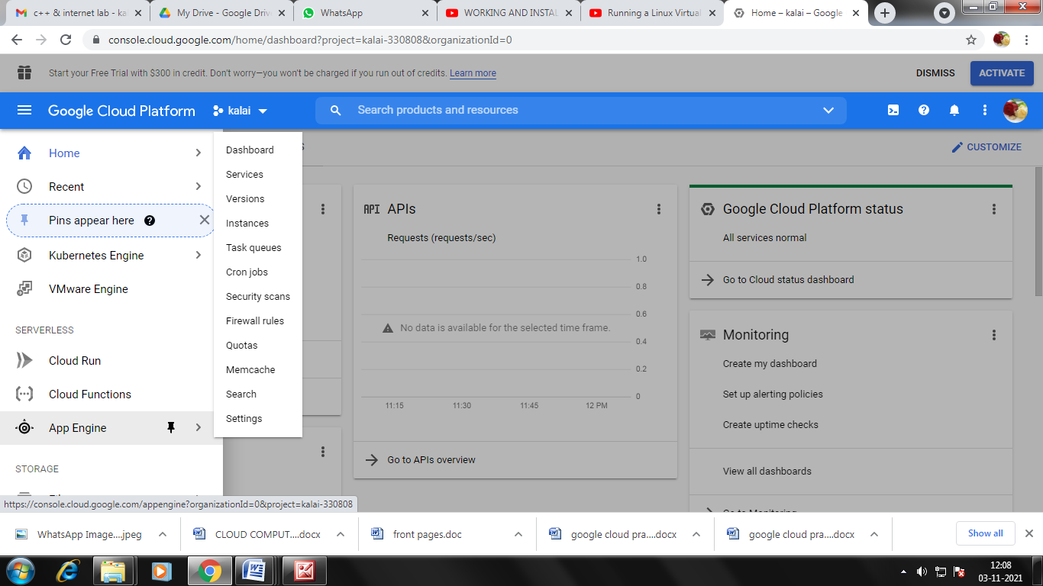

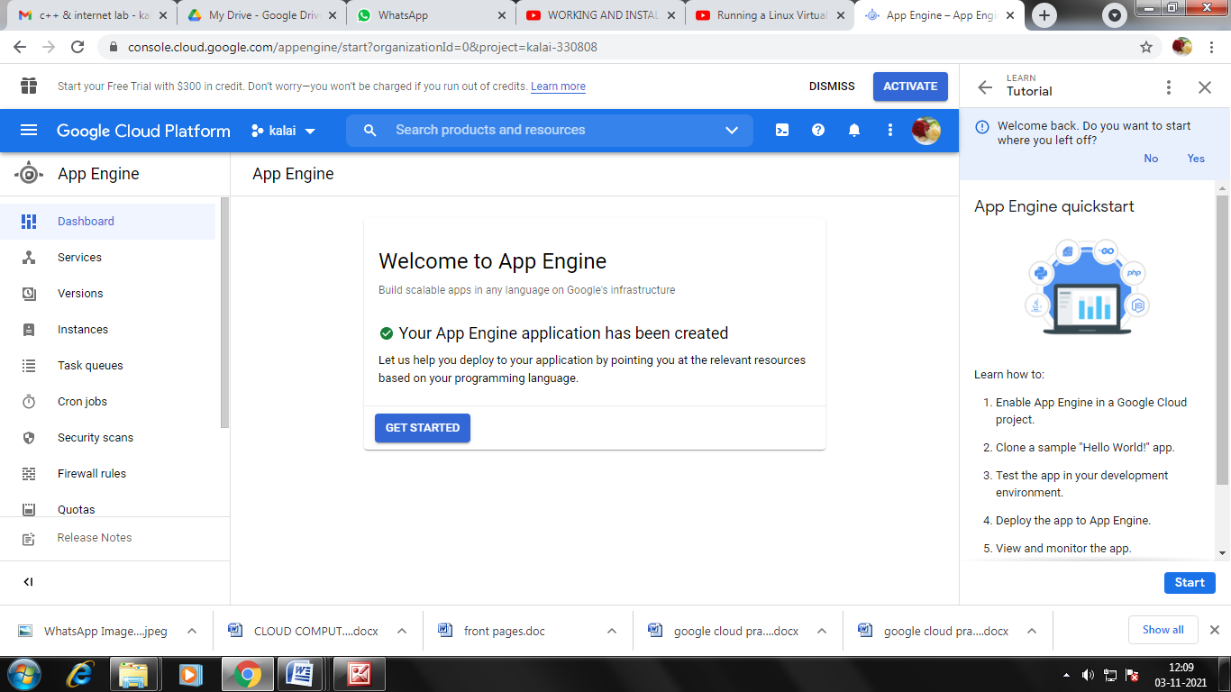

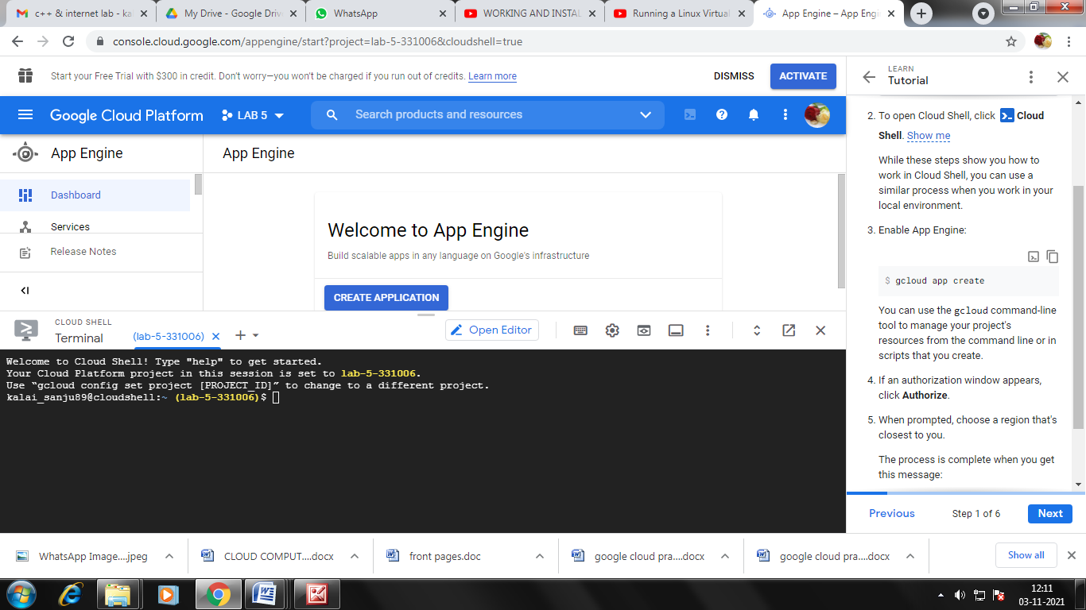

OUTPUT
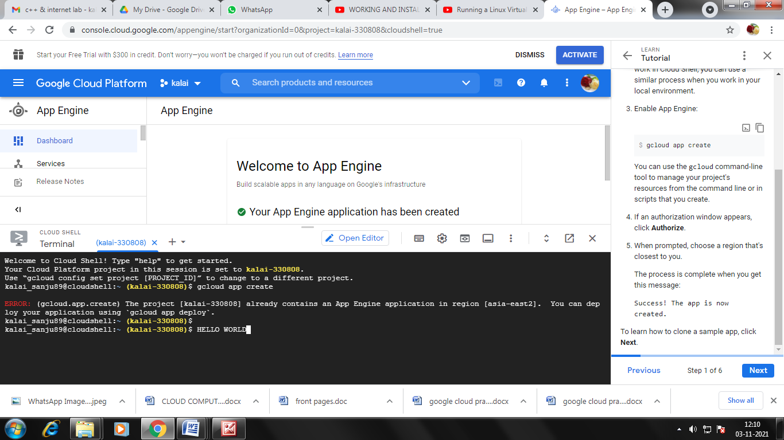

PROGRAM 6

WORKING AND INSTALLATION OF MICROSOFT AZURE

AIM:
To create a program for working and installation in Microsoft azure
ALOGRITHM:
STEP 1: Start the process
STEP 2: Open a link for Microsoft azure free create
STEP 3: Click on start for free
STEP 4: Sign in your Microsoft azure account after given setting it display the window confirmation
STEP 5: Create the SQL database in the azure
STEP 6: Run the program and stop the process

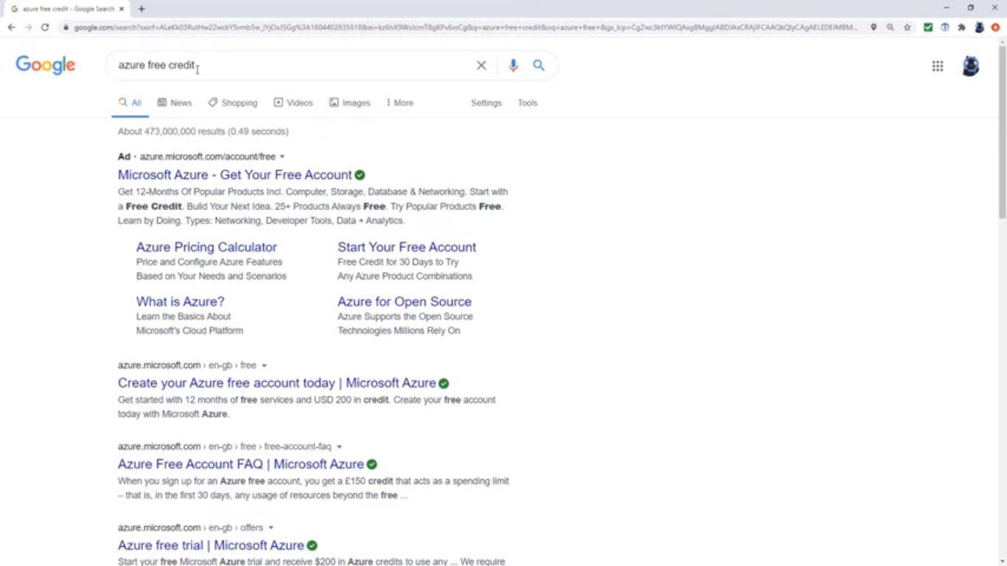

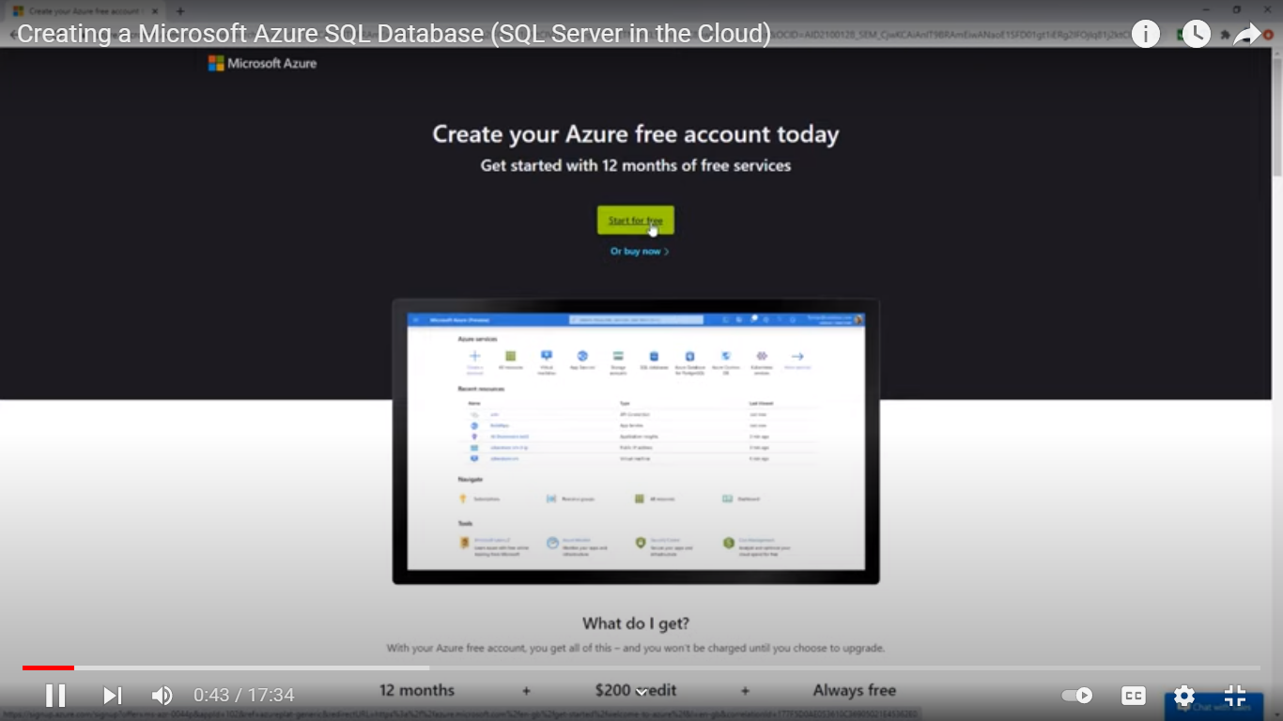

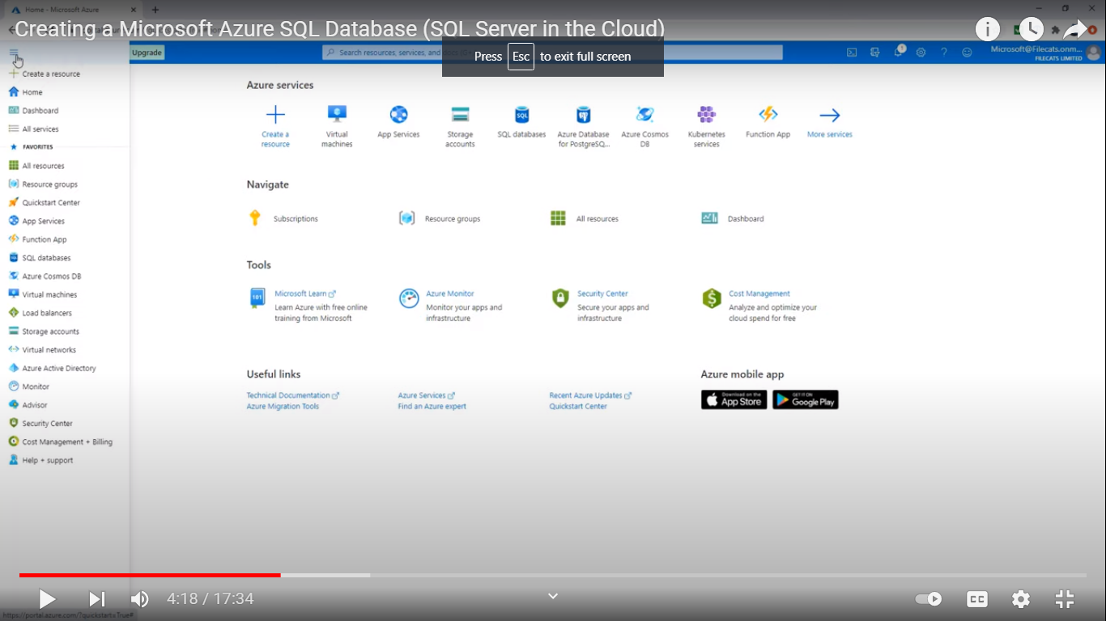

OUTPUT
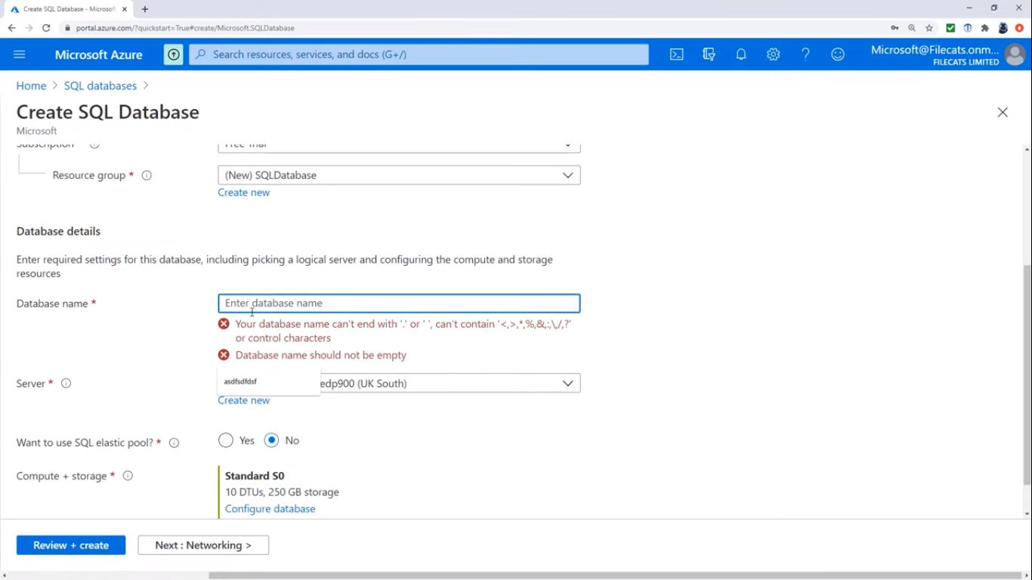

PROGRAM 7
TO CONNECT AMAZON REDSHIFT WITH S3 BUCKET

AIM:
To create a program for connect Amazon redshift with s3 bucket
ALOGRITHM:
STEP 1: Start the process
STEP 2: Login the AWS account and after select the s3 buckets
STEP 3: Crete the s3 bucket name and region
STEP 4: Fill the configure options and set permission
STEP 5: Check the option and click right side it displays the option of created bucket
STEP 6: Stop the process

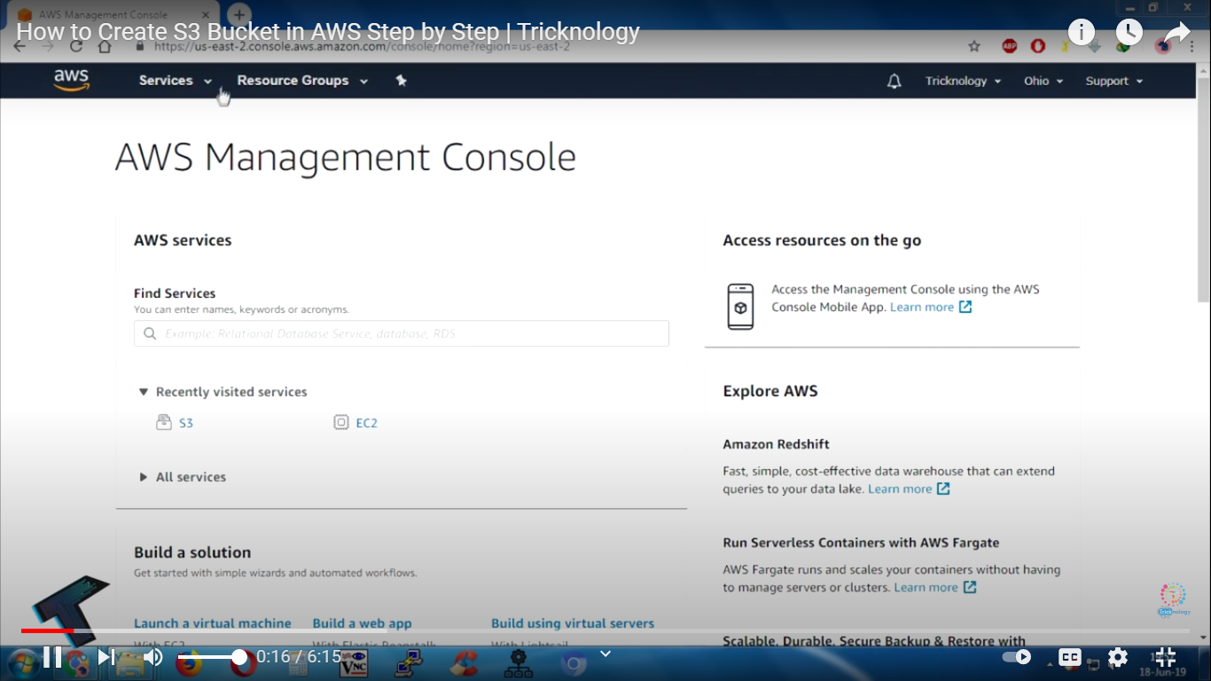

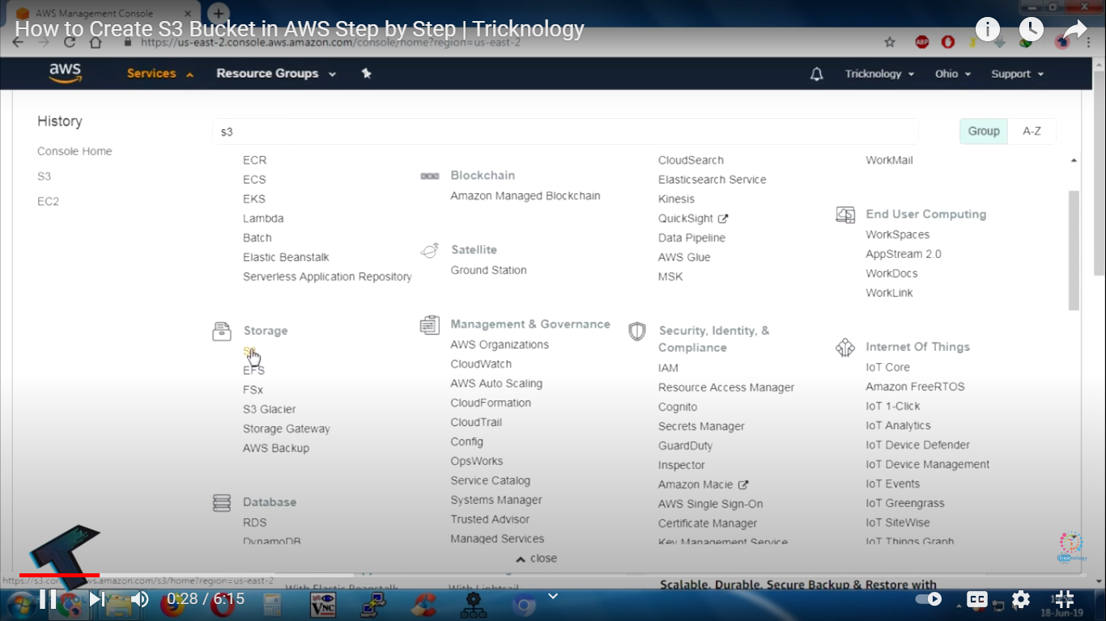

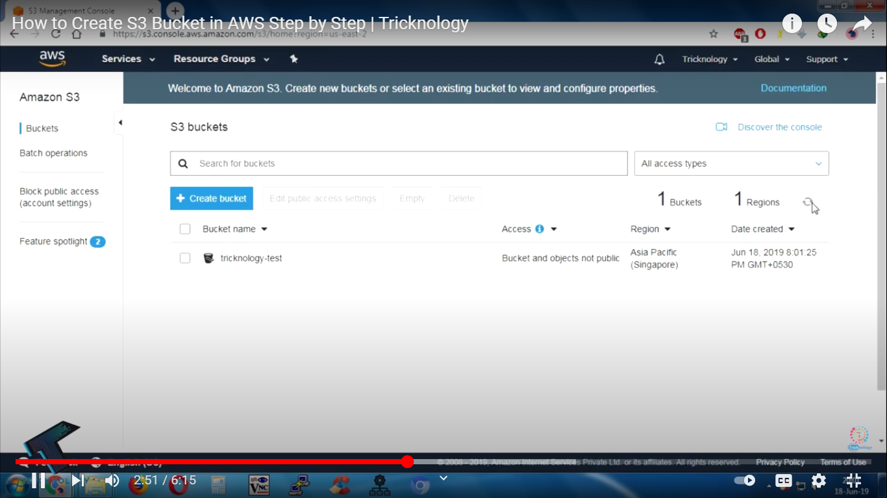

OUTPUT
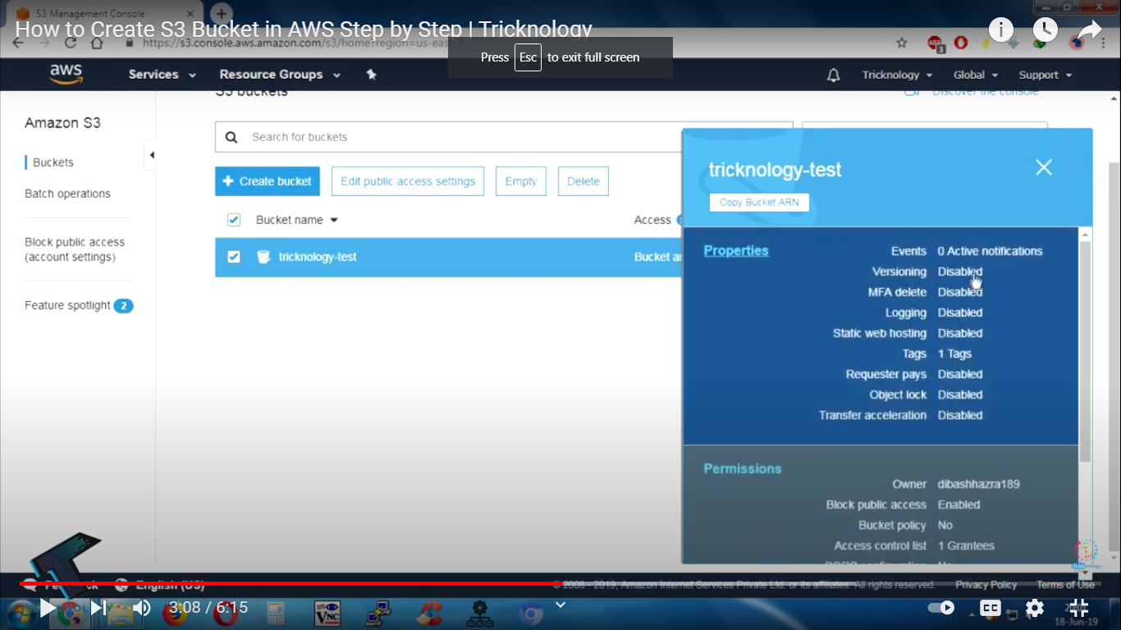

PROGRAM 8
TO CREATE AND QUERY A NOSQL TABLE

AIM:
To create a query a NOSQL table
ALOGRITHM:
STEP 1: Start the program
STEP 2: Open a website console.cloud.google.com for using the Google cloud platform
STEP 3: Click the dash board for opening the big table menu
STEP 4: Create an instance give a name of the instance and ID select the storage type as SSD
STEP 5: Give the cluster name and cluster id and select the location and nodes
STEP 6: Configure your first cluster
STEP 7: Stop the program

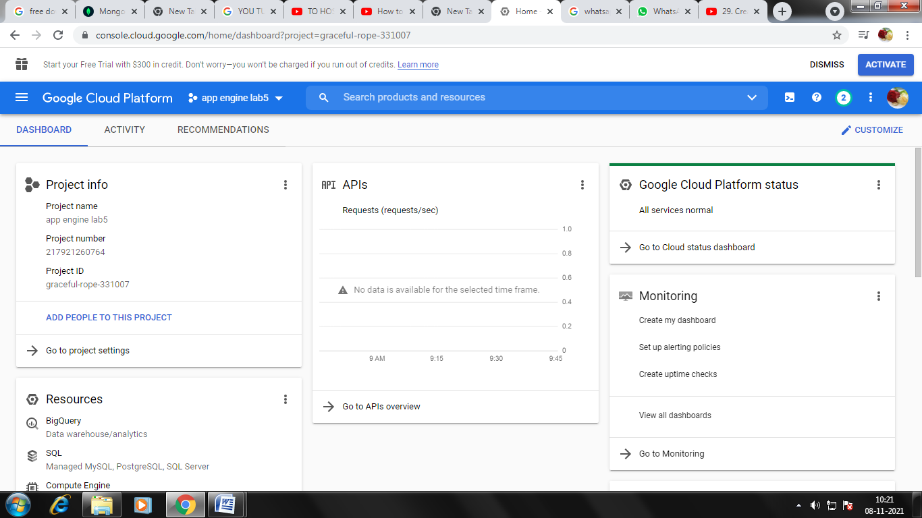

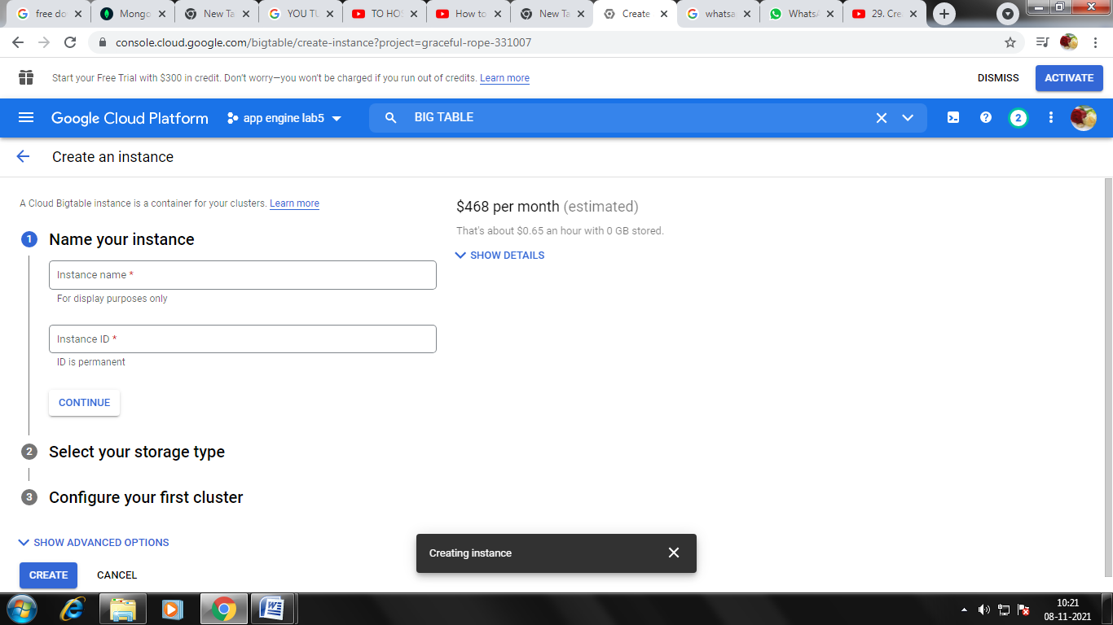

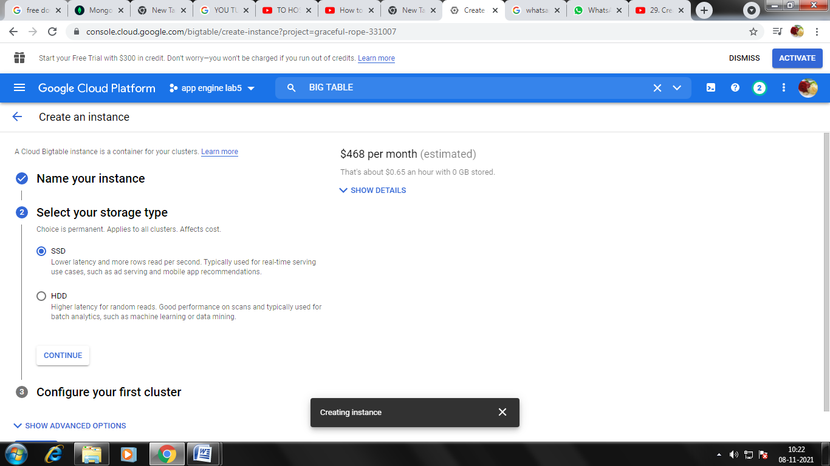

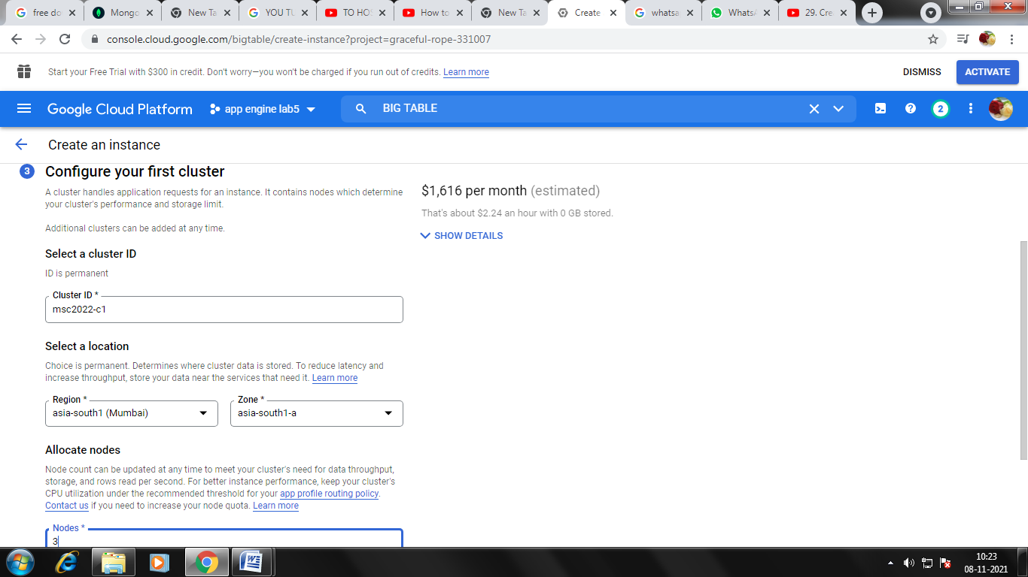

OUTPUT
